# Report CO2 emissions

### Intro

For this report I looked at possible predictors for countries that have high co2 output and at countries that have decreased their co2 output. As well as what energy source could replace fossil fuels the cheapest in the future. I took all the data from the site: Our World in Data.

## 1: Biggest predictor of CO2 output

To find the biggest predictor I looked at the CO2 per capita for countries per year and looked at the Pearson correlation factor between that and the following factors:GDP, Diet, number of new cars per capita, population and population density, energy consumption, Mobility, Military spending and income inequality. I will use the rule of thumb that if the absolute score is between 0.00 and 0.10 the relation is negligible, between 0.10 and 0.20 the relation is weak, between 0.20 and 0.40 the relation is moderate, between 0.40 and 0.60 the relation is Relatively strong, between 0.60 and 0.80 the relation is strong, between 0.80 and 1.00 the relation is very strong.For each factor I will describe the most significant findings, the full results are in notebook 1.

### GDP

The correlation between GDP per capita and CO2 per capita is 0.609 so there is a strong relation between the GDP and the CO2 output of a country which means that richer countries produce more CO2.

### Diet

To see what diets would produce more co2 i looked at the amount of kilocalories per person per day were consummate for different food groups. Those groups are: Alcoholic Beverages, Sugar, Oils & Fats, Meat, Dairy & Eggs, Fruit and Vegetables,Starchy Roots, Pulses, Cereals and Grains. The ones that had a moderate relation were: Oils & Fats with a factor of 0.317, Alcoholic Beverages with a factor of 0.337, Sugar with a factor of 0.356. The ones that had a relatively strong relation were: Meat with a factor of 0.409 and Dairy & Eggs with a factor of 0.415 . This means that countries that eat a lot of meat produce more CO2.

### number of new cars per capita

For this i looked at the number of new cars per capita as well as the number of new cars per fuel source. I found that electric or hybrid new cars have a weak or negligible correlation. The total amount of new cars per capita on the other hand has a factor of 0.778 which is a strong correlation so the amount of new cars in a country is a good predictor for co2 as well as the amount of petrol and diesel gas cars who got a factor of 0.513 and 0.704 .

### Population

Both the total population and the population density have negligible correlation to the CO2 output of a country

### energy

For energy I looked at the electricity generated per capita in kWh and the share of electricity produced for every power generation type such as biofuel and coal and looked at which ones had the biggest correlation. Coal, fossil and gas all had moderate to very strong correlations the highest was fossil per capita which was 0.849. The only other notable correlations were hydro share being -0.273 which means that the higher the share of all generated electricity is hydro power the lower the CO2 output for that county is. As well as the share of all renewables combined which had a correlation factor of -0.277.

### Mobility

For mobility I looked at the amount people travel by plane or train. The correlation for train travel is 0.008 so that is negligible and the correlation factor for plane travel is 0.445 so relatively strong.

### Military spending

I took the military expediture per capita for each country and the correlation with CO2 per capita is 0.639 which is a strong correlation so countries that spend a lot on military also produce more CO2

### Income inequality

Here I looked at the gini coefficient to the CO2 per capita. And the correlation between those two is: -0.433 which is a relatively strong correlation. This means that if the income in a country is more evenly distributed the less CO2 that country produces.

### Conclusion

So the biggest predictor for the factors that i looked at is fossil electricity generated per capita. After that good predictors are: the total amount of new cars per capita and the number of new diesel gas cars per capita. The biggest negative predictor is the gini coefficient of a country.

## 

## 

## 

## 2: Biggest strides in decreasing CO2 output

To calculate the countries and territories who made the biggest strides in decreasing CO2 output I looked at the year where they had the biggest CO2 output per capita and compared that to there most recent CO2 output. For this I looked at the biggest percentage decrease from there maximum CO2 output . The results were as follows.

| **Country or territory** | **Percentage decrease** |
| --- | --- |
| Sint Maarten | 98.216443 |
| Kuwait | 93.212769 |
| Curacao | 91.810830 |
| Brunei | 90.450176 |
| Bahamas | 87.313152 |
| Bonaire Sint Eustatius and Saba | 85.514853 |
| Venezuela | 82.831721 |
| North Korea | 78.737897 |
| Gabon | 76.999949 |
| Nauru | 74.763305 |

## 

## 

## 

## 

## 

## 

## 3: Best future price for non-fossil fuel energy

To find the best price in the future for non-fossil fuel energy I looked at a table with the seven different energy generation methods, these are: Bioenergy, Geothermal, Offshore wind, Solar photovoltaic, Concentrated solar power, Hydropower and Onshore wind. First i tried to look at the future with linear regression but then you would get negative cost really quick which is obviously not possible.

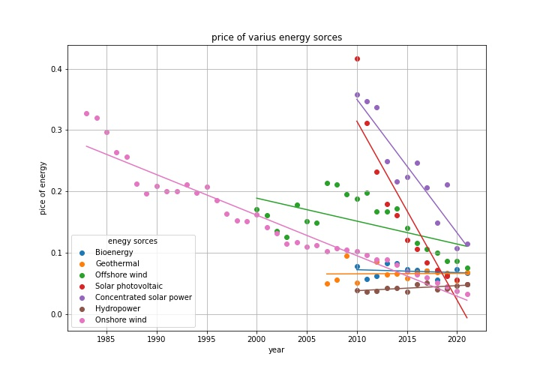

So then I looked at exponential regression in there I came to a way better answer.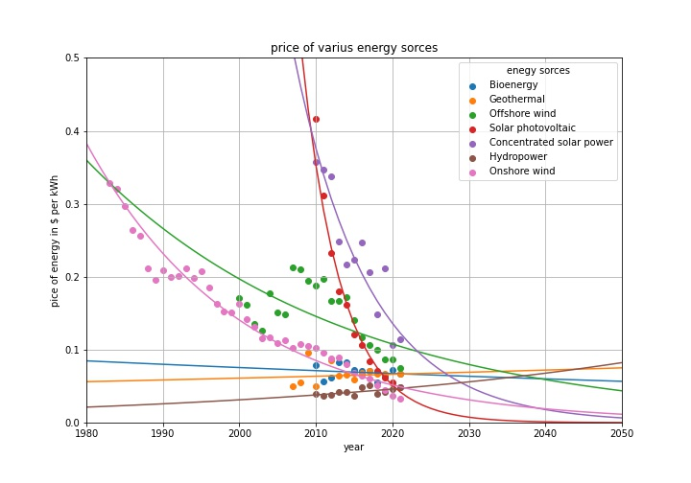

So it's clear that in the future solar power will be the most cost effective form of power.

## Conclusion

So the biggest predictor for CO2 emissions is fossil electricity generated per capita. The Country or territory that made the biggest stridedes in decreasing CO2 output is Sint Maarten. And the cheapest non fossil fuel in the future is solar power

## Appendix

Sources:

All data is collect from our world in data and the following links:

1. <https://github.com/owid/co2-data>
2. <https://ourworldindata.org/co2-dataset-sources>
3. <https://github.com/owid/energy-data>
4. <https://ourworldindata.org/transport#road-travel>
5. <https://ourworldindata.org/grapher/levelized-cost-of-energy>
6. <https://ourworldindata.org/world-population-growth#>
7. <https://ourworldindata.org/diet-compositions#diet-compositions-by-food-groups>
8. <https://ourworldindata.org/military-spending>
9. <https://ourworldindata.org/grapher/economic-inequality-gini-index>